**Week 13 -- the soft opening week**

In week 13, we have our soft opening.We have faculties to play our game and give us feedback for the final.

There are 2 sections in the soft opening. Half of the faculties will come in the morning section and the other half will come in the afternoon section.

As we talked before, we have developed a developer tool for the soft opening. Also, we will ask faculties if they want to play the game or if they want to watch us play. Both strategies work well.

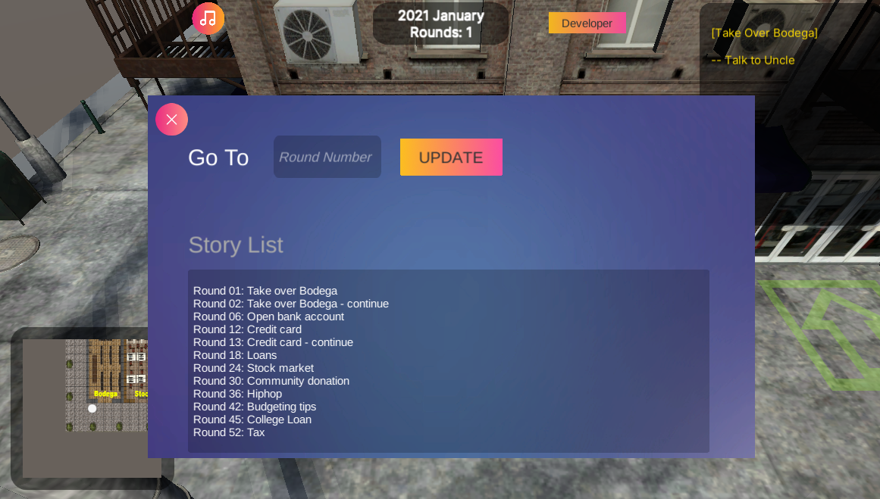

We received plenty of feedback from the soft opening. We are very proud of our game and a lot of faculties praise us for the great job!

Beyond the praises, there are some other jobs that can be changed based on the feedback.

For example, the UI of customers is still kind of confusing and the color in different UI can be modified for a better expression.

In a nutshell, we receive a lot of positive feedback during the soft opening and we will continue polishing our game for the rest of time!